HOME PAGE BANNER:
We made a billing error on July and August bills, and we're sorry. We will not charge late fees on these adjustments, and payment plans are available. See what this means for you →
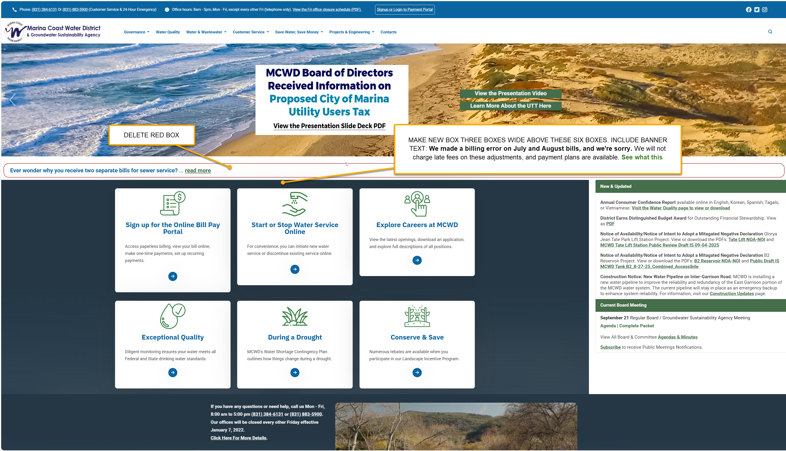

THIS GOES AT THE TOP OF THIS PAGE ABOVE ALL ELSE:
We Made a Billing Error on July and August Bills.
Here's How We're Making It Right
We made a mistake, and we apologize. New water and sewer rates took effect July 1, 2026, but we did not apply them to July bills and many August bills. As a result, we charged you less than the approved rates.
We corrected the error, recalculated the charges on affected accounts, and added a review step to our billing process so this does not happen again.
The adjustment will appear on your October bill and covers only the difference between what you were billed and what you should have been billed. The average adjustment is about $13 for both months combined. Your bill and letter will show your exact amount. You may see the adjustment on your bill before our letter arrives.
We know a surprise charge is unwelcome, especially when the mistake was ours. We will not charge late fees on these adjustments, and we can set up a payment plan that spreads the amount over several months.
If you have questions or need help
Please contact us if you have questions, would like us to walk you through the calculation, or need help paying. We're here to help.
- By phone at (831) 384-6131 or (831) 883-5900
- By email at customerservice@mcwd.org
- Office hours: Monday through Friday, 8:00 a.m. to 5:00 p.m.
We take responsibility for this error. Thank you for your patience as we make it right.

We apologize that the approved water and sewer rates effective July 1, 2026 were not applied correctly to Most July and August water and sewer bills, resulting in undercharges.
We have corrected the error and recalculated the affected charges on the affected accounts.
The adjustments are appearing on October statements and covers only the difference between the original charges and the charges under the approved rates.
We understand that an unexpected adjustment can be frustrating, and we sincerely apologize for the inconvenience. We have suspended late fees while the District completes these billing adjustments and can work out payment plans upon request.
If you have questions or need assistance
If you are experiencing financial hardship and need assistance, or have questions about the changes, please contact us. We are here to help.
- By phone at (831) 384-6131 or (831) 883-5900
- Or email customerservice@mcwd.org.
- Office Hours: Monday through Friday, 8:00 a.m. to 5:00 p.m.
We take responsibility for this error and appreciate your patience as we correct it.

July and 60% of august billing for all customers had old rates rather than the new rates
Spent September figuring it out.
Sent a letter to all 11,500 accounts affected (get letter). The Letter was kind of heavy – and an FAQ, then an apology in one line. Sounded cold. Half of the letters went out. The rest were stopped. Mary rewrote it a little simpler and warmer – it will take two weeks for those to print and mail. In the meantime, people are receiving their updated bills.
The average adjustment is $6.50 per month for sewer and water. It is a two-month bill, so the average is $13.
If you have questions, please contact customer service,
If you have questions or need assistance
We understand that unexpected account adjustments can be concerning. Our Customer Service team is available to answer questions and discuss payment options.

- By phone at (831) 384-6131 or (831) 883-5900
- Or email customerservice@mcwd.org.
- Office Hours: Monday through Friday, 8:00 a.m. to 5:00 p.m.
Our customer team is here to help. If you have difficulty paying, we can help by not charging late fees, working out a payment plan, etc.
A director (Williams) is upset and pressing management on this.
DELIVERABLES:
Banner on homepage that leads to inside page
Explanation at top of ways to pay your bill page: Ways to Pay Your Water Bill | Marina Coast Water District

JEAN: LET’S TALK: FOG: Fog inspection – let them know of a new fee in March. Mary says the charge should not be a big deal on eblast or at all.

